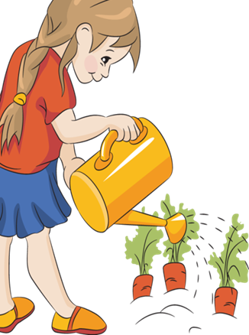

**Today at NDOG Kidz Klub**!



**Kidz Klub**

**Happy 4th of July!**

**Today the kids will be working in the garden and will harvest their first produce . . .**

**Then they will do some fun crafts!**

**Each week, 8am – 9:30am, May 12 – August 11, NDOG volunteers will provide fun crafts and learning activities to children ages 3 – 10. Visit the garden during market hours for more information or contact Sherry Wenta at (870) 845-0134.**



